EXPERIMENT-5

AIM:
To analyze the histogram of the given input image based on color levels using OpenCV.
PROGRAM:
import cv2
from tkinter import Tk, filedialog
from matplotlib import pyplot as plt
# Hide Tkinter window
Tk().withdraw()
# Select image
file_path = filedialog.askopenfilename(
title="Select an Image",
filetypes=[("Image Files", "*.jpg *.jpeg *.png *.bmp")]
)
# Check if image selected
if not file_path:
print("No image selected!")
exit()
# Read image
img = cv2.imread(file_path)
if img is None:
print("Error: Unable to load image!")
exit()
# Display original image
cv2.imshow("Original Image", img)
# Plot histogram for B, G, R channels
colors = ('b', 'g', 'r')
plt.figure("Color Histogram")
for i, color in enumerate(colors):
hist = cv2.calcHist([img], [i], None, [256], [0, 256])
plt.plot(hist, color=color)
plt.xlim([0, 256])
plt.title("Histogram of Color Image")
plt.xlabel("Pixel Intensity")
plt.ylabel("Number of Pixels")
plt.show()
cv2.waitKey(0)
cv2.destroyAllWindows()
INPUT:
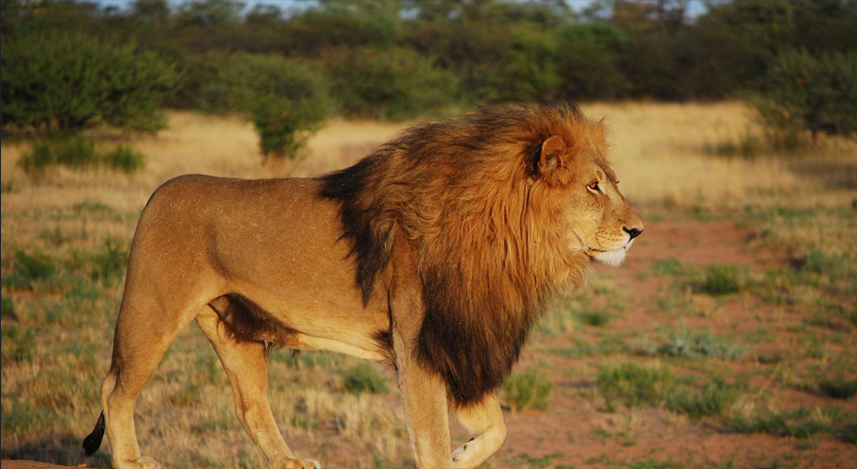
OUTPUT:
